Educational passport
blockchain-based academic record platform
Student ID: 933678
Name: Zepeng Dan

Abstract
Bothered by the redundant procedures of verifying academic record in many scenarios, we propose to build an educational passport system named Epass, which provide a shortcut for verifying, storing and transfer certificate document without security loss, basing on blockchain technology. Combining the characteristic of trustworthy and security of blockchain technology, this system will solve the problem produced by traditional paper document. The blockchain technology create a decentralized ledger that securely stores immutable information such as grades and successful subjects of an individual. With more research and practice devote to blockchain field, the concept of smart contract is proposed in which the transaction can not only be virtual currency but also well-programmed agreement. By taking advantage of smart contract technology, Epass will reduce the redundant operations needed for verifying documents face to face from multiple parts and most of the work will be automatically handled conforming to the “agreement”. Certificate storing, verifying and issuing are move onto the production line of block.

Literature Review
The fast arising of cryptocurrency Bitcoin[1] and altcoins have opened up new possibility for building a new future of digital currency. However, what the bitcoin brings for society is not limited to digital currency in financial field. With the assistant of Ethereum[2] technique, the infrastructure, blockchain, behind bitcoin is blasting in almost every field of world of internet. The Ethereum technique expend the core idea of cryptocurrency to a wider application scenario-smart contract[3]. Not only virtual currency could be store on the blochchain, but user-defined program could be running on the blockchain together with the contract which defines rules and interaction among the programs. The blockchain technology creates a decentralized ledge where no third part actually govern and control the record on the blockchain.
The incredible growth of blockchain and smart contract technology force the increasing of varieties of problem-solving applications. For example, clinical trails and data access management platform is built basing on blockchain in the healthcare area[4]. The application keeps track of health records electronically basing on the security and trustworthy of blockchain.
In this paper, we pay our attention to the field of higher education, especially on treating academic record with blockchain. Some institutes have made effort in this area. Sony Corporation and Sony Global Education[5], which is the subsidiaries of Sony company, developed the technology that securely transmit data between two specific part such as academic proficiency records. With the accomplishment of such infrastructure basing on blockchain, any evaluating organization could access to the test result of individuals. That will greatly reduce the work of certifying and emailing paper documents.
The Joint Research Centre (JRC) of European Commission use the concept self-sovereign identity of blockchain, meaning that individuals store their own identity as a token on personal device.[6] Certifications are transferred on the blockchain as a currency when one issue a certificate to another. When considering the growth in size of blockchain, they propose to build the system on private or permissioned chain.
Besides, the concept of blockcert proposed by MIT media laboratory, is combined into to the system for dealing with issuing and verification problem.[7]
As a pilot program developed by Dubai, Educhain is based on the concept of academic passport.[8] People can then view, manage, and share academic record for school transfers, university applications, and job applications. Academic institutions can issue digital credentials, cutting processing time and costs while placing ownership of academic records into the hands of students and providing them with global mobility
Proposed by Muamed, a blockchain-based higher education credit platform, called EduCTX, is built. Considering the concept of European Credit Transfer and Accumulation System (ECTS), the EduCTX platform ECTX is designed to be the token representing the credit student gained.[9]
Distinguished from other solutions, what Kirill proposed is a more general approach that includes wider range of knowledge gaining ways. Large university, small institute, schools and online education platform are all beneficiaries of the education blockchain.[10]. Just as the open university described, this scenario can be applied to different levels, from small learning event to years of university degree gaining.[11]

Background
As a proof of education experience, diploma is a form a verifying document widely used in the world for hundreds of years.[12] Act as a formal document, certificates cover plenty of aspects in education. From the diploma for finishing junior high school to graduate certificate for doctor degree, individuals have to keep track of their paper documents over the course of their studying career. With the facilitation of modern internet technique, much of the redundant materials are not necessary since works, like recording, tracking and verifying diploma, could be done on network. However, there are still a great number of procedures when facing with the problem of verification. For example, graduate studying application requires us to hand in bachelor degree certified paper documents, highlighting the complexity and inconvenience of traditionally certified education documents.
Blockchain technology is a growing area of interest for many organizations, companies and universities. Blockchain technology create a decentralized environment in which “transactions”, transferring of digit currency or virtual commodity, on the blockchain are visible to all its participants. Besides, based on consensus mechanism, blockchain technology makes sure that any record (block named in blockchain technique) on the blockchain will never be not altered. As we could imagine, if blockchain technology is paved as the infrastructure for academic record system, procedure of verification could be highly limited. Not only used for education background verification but also some more convenient usage could be created, such as for employment.

Objectives
In this research, we propose to analyze and build an “Education Passport” system (shorten as Epass) basing on blockchain technology. The Epass system works as a public academic record on the blockchain. Any institutes could verify the authenticity of someone’s education background on the blockchain by tracing back the education history. The education record on the blockchain is trustworthy since it will be verified before added to the blockchain and can’t be altered.
For individuals, any education experience will be certificated and recorded on the blockchain. The education experience certifying is not limited to long term studying such as graduating from undergraduate studying but could be appropriate for wider range application including receiving ATAR score for high school learning, receiving a certificate from online course, graduating from post-professional education and non-terteriary education etc.
For institutes, verifying authenticity of individual’s academic record is simple to be accomplished. Even if the institutes providing the certificate do not exist anymore, people can still finish the checking process since the data is not just store in centralized server.

User Case
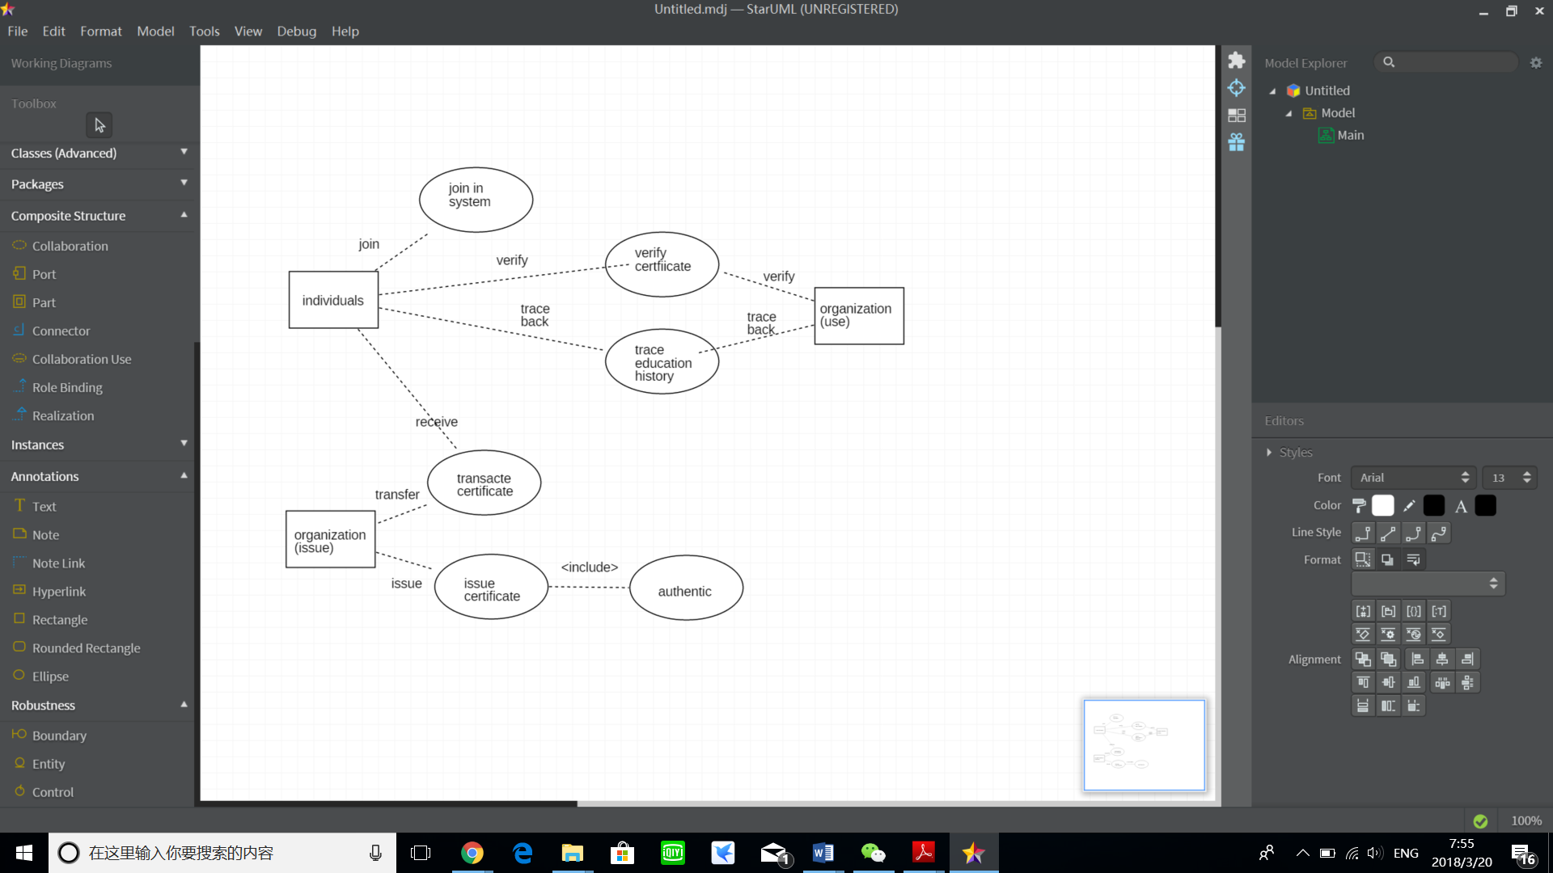

Entity Relationship
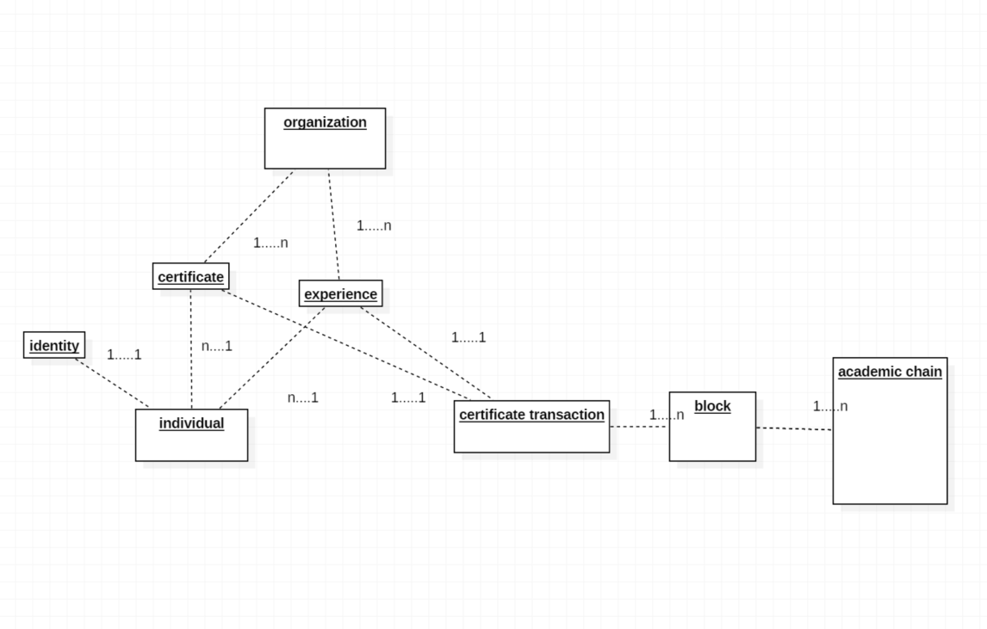

Reference
[1] Satoshi Nakamoto. Bitcoin: A peer-to-peer electronic cash system. 2008.
[2] Gavin Wood. “Ethereum: A secure decentralised generalised transaction ledger”. In: Ethereum Project Yellow Paper 151 (2014).
[3] Buterin V. A next-generation smart contract and decentralized application platform. white paper. 2014 Apr.
[4] Z. Shae and J. J. P. Tsai, ‘‘On the design of a blockchain platform for clinical trial and precision medicine,’’ in Proc. Int. Conf. Distrib. Comput. Syst., Jun. 2017, pp. 1972–1980. [Online]. Available: http://ieeexplore.ieee.org/document/7980138/
[5] Sony Global Education is developing a blockchain to share educational records: www.sony.net/SonyInfo/News/Press/201602/160222E/index.html
[6] Grech A, Camilleri AF. Blockchain in Education. Joint Research Centre (Seville site); 2017 Nov.
[7] Schmidt, P. (2016). Blockcerts — An Open Infrastructure for Academic Credentials on the
Blockchain. MLLearning (24/10/2016)
[8] Educhain enables instant issuance and authentication of digital records for institutions, corporates, and governments. https://educhain.io/press.html
[9] Turkanović M, Hölbl M, Košič K, Heričko M, Kamišalić A. EduCTX: A blockchain-based higher education credit platform. IEEE Access. 2018 Jan 5.
[10] Kuvshinov K, Nikiforov I, Mostovoy J, Mukhutdinov D, Andreev K, Podtelkin V. Disciplina: Blockchain for Education.
[11] Sharples M, de Roock R, Ferguson R, Gaved M, Herodotou C, Koh E, Kukulska-Hulme A, Looi CK, McAndrew P, Rienties B, Weller M. Innovating pedagogy 2016: Open University innovation report 5.
[12] Duranti, Luciana (1989). "Diplomatics: New uses for an Old Science". Archivaria. 28: 7–27 (12).
[13]https://en.wikipedia.org/wiki/Diplomatics#cite_note-9

